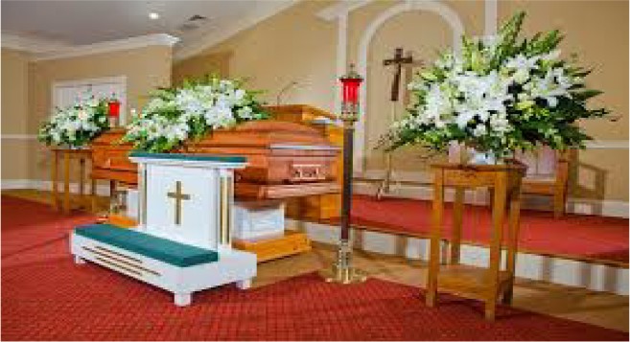 | When people die, their family has a funeral. A funeral is a special event where people go to say goodbye to someone who has died. A funeral is usually at a church, temple, or funeral home. I am going to a funeral for my special person.
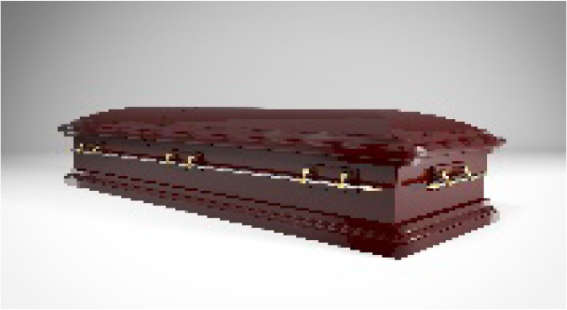 | My special person maybe lying in a casket. A casket is a special box for people who have died. I need to remember that my special person’s body has stopped working and cannot see, hear, or feel anything.
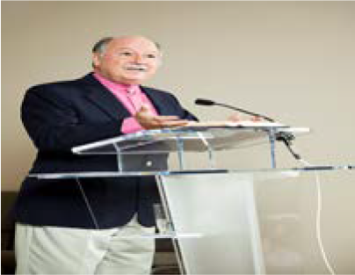 | At a funeral, people may say prayers or may tell special stories about my special person. I will sit quietly when people are praying and talking.
 | At the funeral, people will be sad and they might cry. I may be sad and cry. That is OK. If I am having a hard time, I can tell my mom, dad or favorite adult. They will help me.
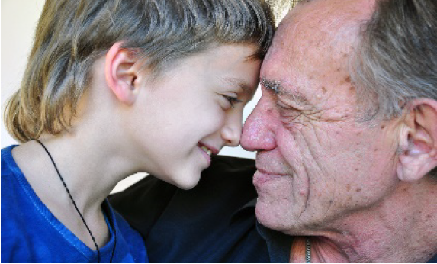 | I can think of the fun times I had with my special person. Soon I will feel better and be happy again. I know my special person will always love me and I will always love them.

